(Approx. 1,349 words)

On the First Day of Christmas, My True-Geek Gave to Me
By Lou Torraca, President, The TUG MOAA Computer User Group, Hawaii
www.the-tug.org
af06hi (at) gmail.com

This article has been obtained from APCUG with the author’s permission for publication by APCUG member groups; all other uses require the permission of the author (see e-mail address above).

On the first day of Christmas, my true-geek gave to me…

Hard to believe, but as of the 1st of this month (November) u have 54 days to get hoppin’ and get your true-geek something they will love/cherish/adore/do flips over/…whatever. So, as I have in the past I have scoured the ‘net and here is my wish list for the first 6 days…tune in on the 1st of December for 7-12…that should take care of the conservative shoppers who want their gifts ready to go well ahead of THE day and the last minute shoppers who always wait to see if the price goes down on Christmas Eve!! BTW, as always, I would advise potential buyers to surf the net to compare prices

So, here goes.

First Day, the iGo folks have done it again! If u are a road warrior or just an occasional traveler; u probably own a netbook so iGo has just the goodie 4 u- a net book charger that also, like their Charge Anywhere.........will charge a slew of other stuff, like iPhones, cell phones, iPods, PDAs, cameras, u name it they charge it!
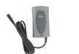

This small gem fits nicely in your bag and includes a pouch for your tips, which is how it charges all the stuff u travel with so u only have to carry one charger, not a bunch!
The iGo Netbook Home/Office Charger is perfect for powering virtually all netbook computers from your home or office.
NOTE: The netbook charger comes with multiple tips that work with the vast majority of netbook computers. You do not need to select a laptop tip, however you are eligible for an additional free tip so u can select one for your cell phone, player, etc. The tips are not that expensive, so u can afford to get one for each of your gadgets. BTW, this particular charger doesn’t work for a full-size laptop, so, if u need to carry both, go for the laptop charger which will also charge the netbook. [Why u would want to lug that heavy, old laptop along I can’t imagine {:-)].I bought a cellphone tip for my Pantech C3B and used the charger, with the USB cable plugged in, to charge my netbook and cellphone at the same time and tried it both using the wall plug and the car plug. Not a scientific result, but I think both times the recharging was faster than with the factory supplied chargers! Finally, now that u seem to be interested, I have inserted a gallery of all the neat things iGo has for u. Go to their webpage at www.iGo.com to match the pictures and read the details. While u are there you can pick up some for Christmas.
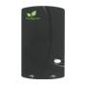
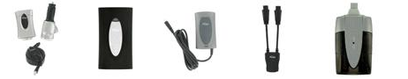
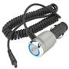
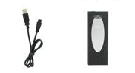

The 2nd Day is for all u iPhone lovers…gotta protect that investment, right? Otter box has the solution with their Commuter and Commuter TL series for the 3G and 3GS Available in 7 vibrant colors, the OtterBox Commuter™ TL Series for iPhone™ 3G/3GS incorporates 3 slender, yet sturdy layers to provide superior protection with STYLE. First, apply the self-adhering film to protect your touch screen from scratches and dings.
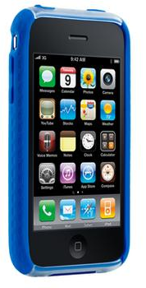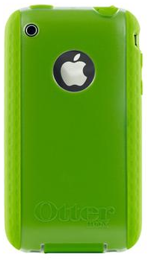

The second layer is a textured silicone skin with inner-coring, designed to dissipate shock AWAY from your iPhone. The outside of the case is a translucent plastic shell that clips around the spine of the silicone adding extra support. Your access ports are protected with tight, silicone plugs to keep them free of dust and debris. This case was designed to slide easily in and out of your pocket or purse.

Interactive and trend-setting, the OtterBox Commuter™ Series for iPhone™ 3G/3GS includes 3 slender, yet sturdy layers to safeguard your precious Smartphone.
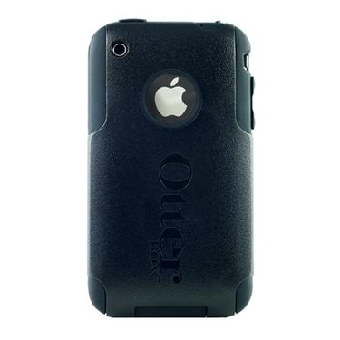
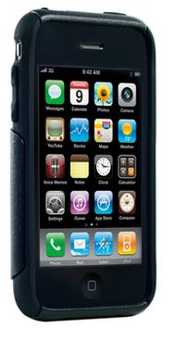

First, a self-adhering clear film protects your touch screen from scratches. Second is a soft, silicone skin that wraps around your device. Finally, a one-piece, custom molded polycarbonate shell hugs tightly around the silicone. While in the case, all functions of the iPhone remain fully intact. Plus the silicone plugs provide access to all ports while keeping out dust and debris when not in use. This case was designed to slide easily in and out of your pocket or purse.
Visit www.Otterbox.com for pricing and availability.

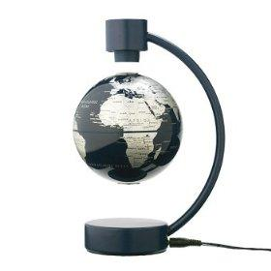
The 3rd day is for fun one I could not resist! Put it on your desk, next to your computer or on the coffee table. Amazon has it for what I think is probably the best price.

How the floating globe works:

It's a simple premise: put magnets of opposite poles on the top and bottom of the globe. Their forces should cancel out and the globe will levitate. The theory is great except that it would require a globe that is perfectly spherical and with a completely uniform distribution of weight. Basically, this would require a magnetic levitating globe created by NASA engineers using $15,000 hammers.

The next logical step is to create magnets that can adjust their forces based upon changing conditions. For instance, if there's a little wind in the room that forces the globe in one direction or pushes it slightly up or down, the magnets could adjust their forces and keep everything balanced.
That's exactly what the Magnetic Levitating Globe does. In the top of the frame, there is a sensor that measures the magnetic field to measure the height at which the globe is suspended. In the bottom of the base, there is a microcomputer that adjusts an electronic magnet in the upper part of the frame in order to maintain suspension.
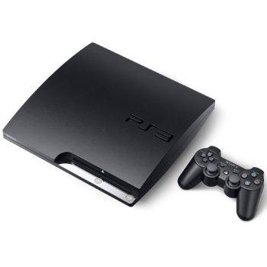
And for the 4th day…If u still haven’t gotten the bug; this might be the one to change your mind:
Sony PlayStation 3 Slim (120GB)

CNET Editors give it 4 stars and have this commentary: The newly redesigned PlayStation 3 comes with 120GB of internal storage and is almost 40 percent thinner than the original PS3.THE BOTTOM LINE: With a smaller design, more energy-efficient operation, lower price tag, and built-in Blu-ray and multimedia capabilities, the PS3 Slim delivers a compelling package for an affordable price. ($299)

For the 5th day a must-have practical gift: OWC Mercury On-The-Go Pro™ Bus Powered Portable Solutions-Safely and Conveniently Transport Large Amounts of Data Compact and versatile - No AC Adapter Required!
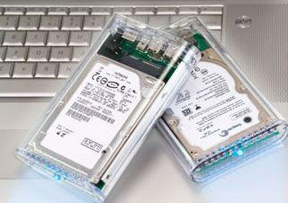
High-Performance 2.5" 5200RPM, 5400RPM, 7200RPM, and SSD solutions with up to 64MB data buffers gives you maximum storage in an ultra-portable, totally bus powered design. Stylishly engineered in a sleek, impact-resistant acrylic enclosure, the Mercury On-The-Go Pro incorporates shock-isolation technology to give maximum protection for your precious data inside. The Mercury On-The-Go Pro is a true must-have for users like you who are seeking High-Performance and Highly Reliable storage weighing less than 11 ounces and that is small enough to fit in your shirt pocket. Take a look at the wide variety of choices with regard to size, capacity, etc. at: http://tinyurl.com/nrpud

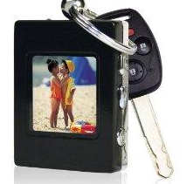
Finally, the 6th day brings an excellent choice for a stocking stuffer that will not tax your budget and bring smiles to one and all, a digital picture key ring available on Amazon.

Technical Details
1.4-inch LCD color screen
Supports JPEG and BMP photo formats
Stunning slideshow effects with time and date display feature
Internal rechargeable battery provides up to 3 hours of viewing
Connects to your computer via included USB cord
Product Description
Keep your precious memories at your fingertips with this Digital Photo Keychain. With an ultra bright 1.4-inch LCD color screen and able to store up to 60 colors photos, this keychain makes the perfect companion to any set of keys. Never leave home without pictures of your family, friends, or pets again.

Aloha, Lou



